**CSS3 (Module-3, 4, 5, 6)**

1. Create CSS effect as shown in the image below using following CSS properties:

Background and borders, opacity, text shadows, pseudo classes.

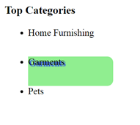

1. Rotate the image using CSS effects.

 

1. Show the zoom-in effect for an image using CSS properties:

 

1. Show the zoom-out effect for an image using CSS properties:

 

1. On Image Hover, it must become transparent. Implement using opacity.

 

1. Display Multiple Background images as shown below:

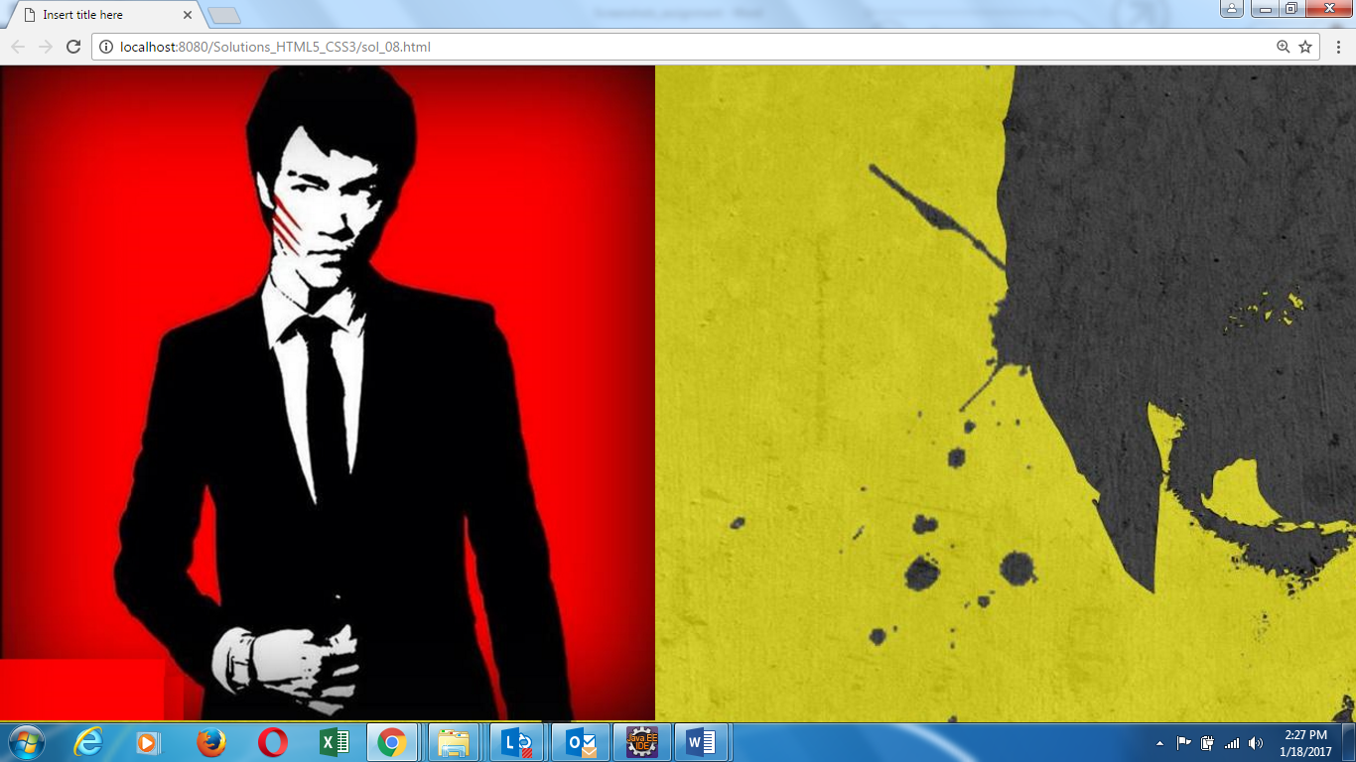

1. Display Multiple Background colors as shown below:

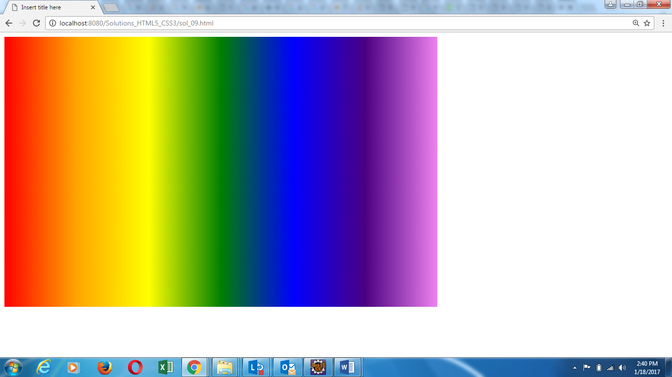

8.Display static, fixed, absolute and relative positions using divs.

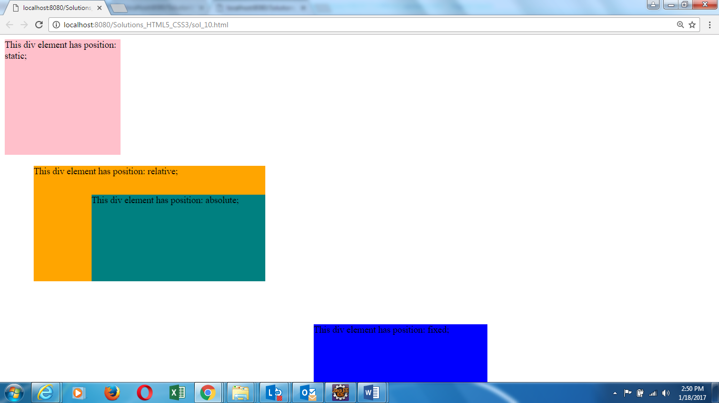

1. Create a Multi column layout of a webpage as given below:

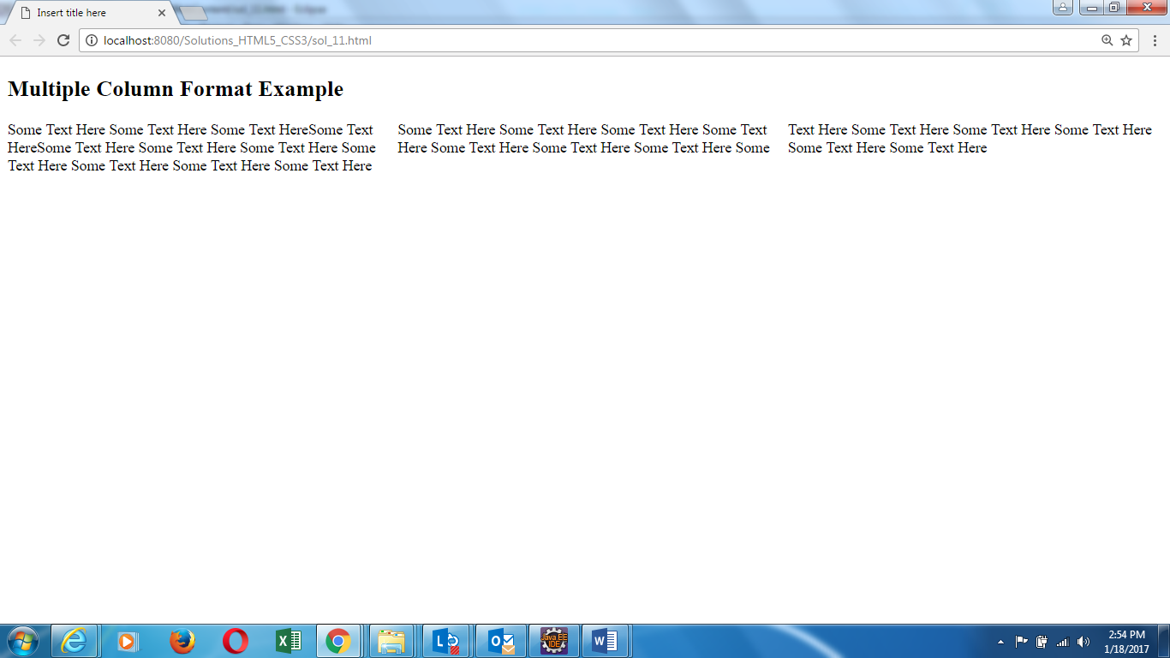

1. Write some text in transparent box. Implement this using opacity and background-image

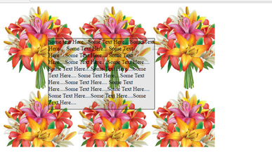

1. Add a border when image is hovered. If possible show hover state for any of the image.



1. Implement using input: focus

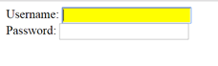

1. Implement a horizontal menu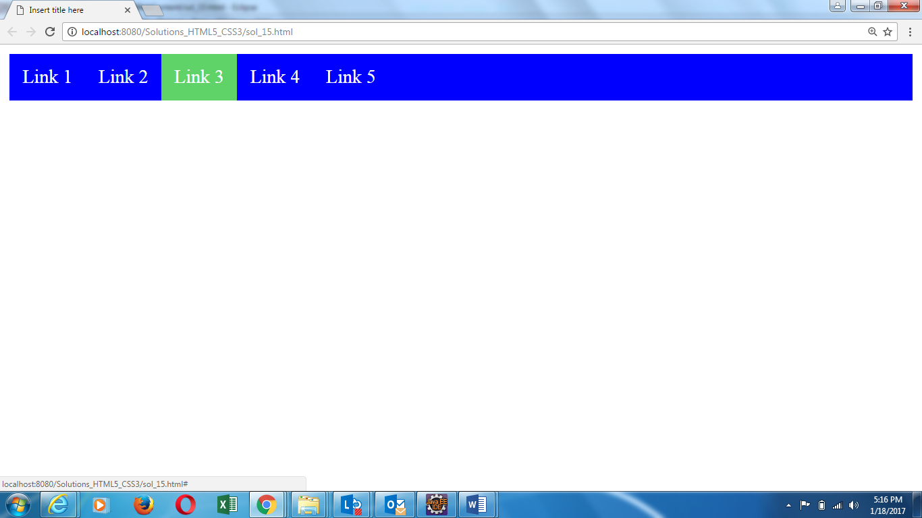
2. Create 3 paragraphs using HTML <p> tag. Select the first letter of every paragraph and change its font-size to 200% and text-color to red. (HINT: use pseudo elements)

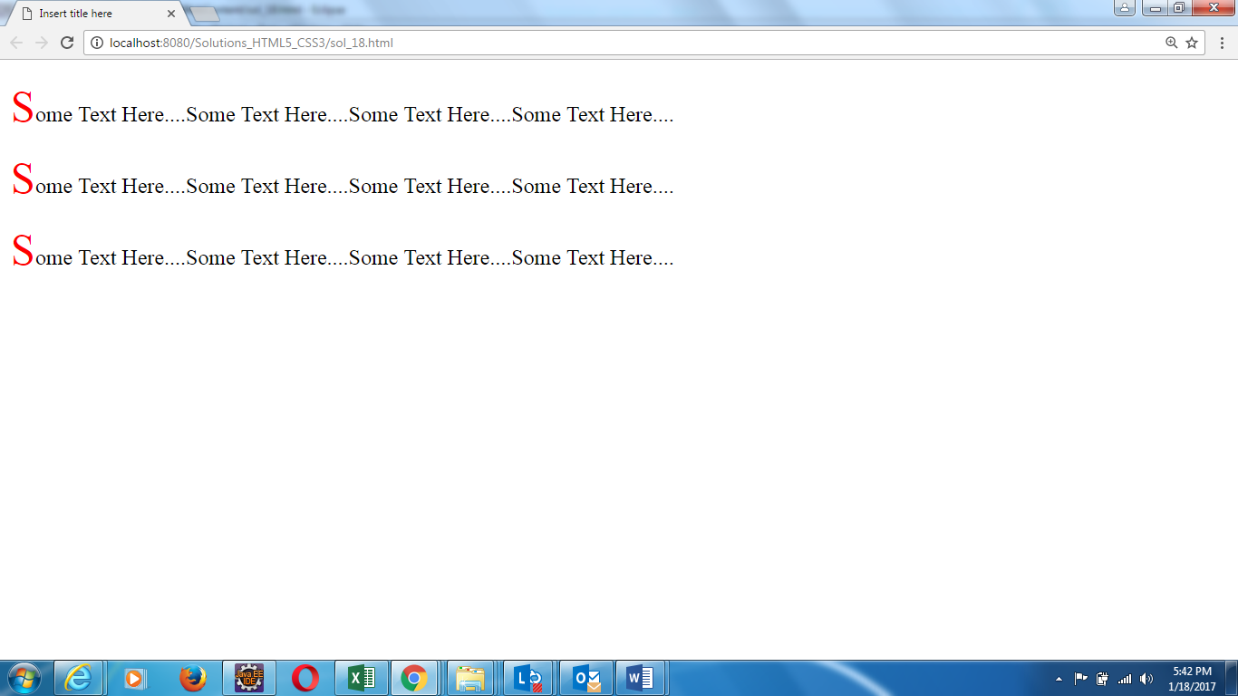

1. Create a hyperlink on your HTML document. Change the color of the link , on change of its state as specified: (HINT: use pseudo elements)

-when the link is visited: green color

-when the link is active: blue color

-when the link is hover: yellow color

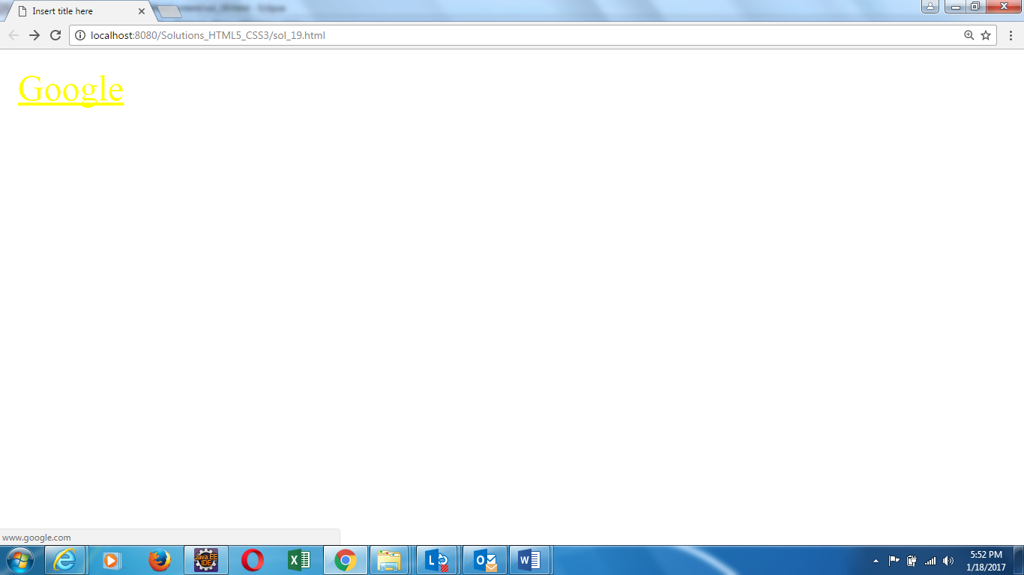

1. Create a paragraph in your HTML document. On selecting text of that paragraph, change the background color of selected text to yellow. (HINT: use pseudo elements)

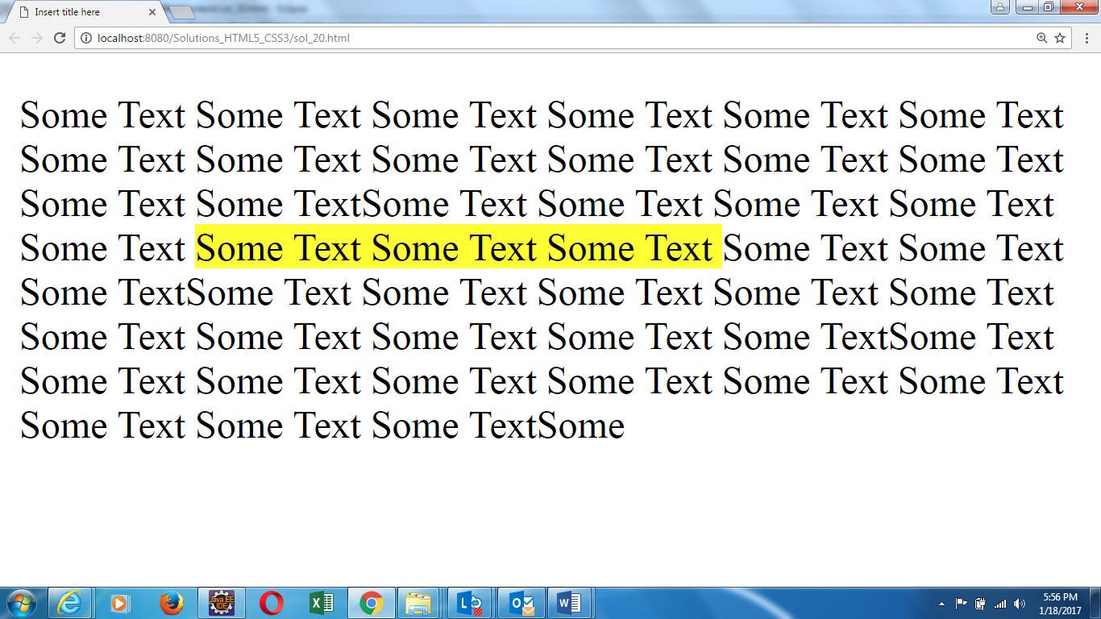

1. Create 3 div tags with background color as red, green and blue resp. Stack these div tags on one another as given below using z-index property of CSS.

